BIM User Guide: October 2022 2022
ACO Frameline and Frame Box

User Guide for Autodesk Revit files

ACO Frameline and Frame BoxPackage

ACO Frameline and Framebox is incorporated in a single Revit template along with its accessories. This template includes three families as assemblies, and five nested families as shown below;
- Main Assembly Families:
- PF_WPB_Framebox_ACO
- PF_WPB_Frameline_ACO
- PF_WPB_Frameline cross channel_ACO
- Nested Families :
- ZZZ_do not use_PF_WPB_Fit-in height adjuster_ACO
- ZZZ_do not use_PF_WPB_Framebox drain socket_ACO
- ZZZ_do not use_PF_WPB_Frameline cross channel connector_ACO
- ZZZ_do not use_PF_WPB_frameline gratings_ACO
- ZZZ_do not use_PF_WPB_Gravel bar_ACO

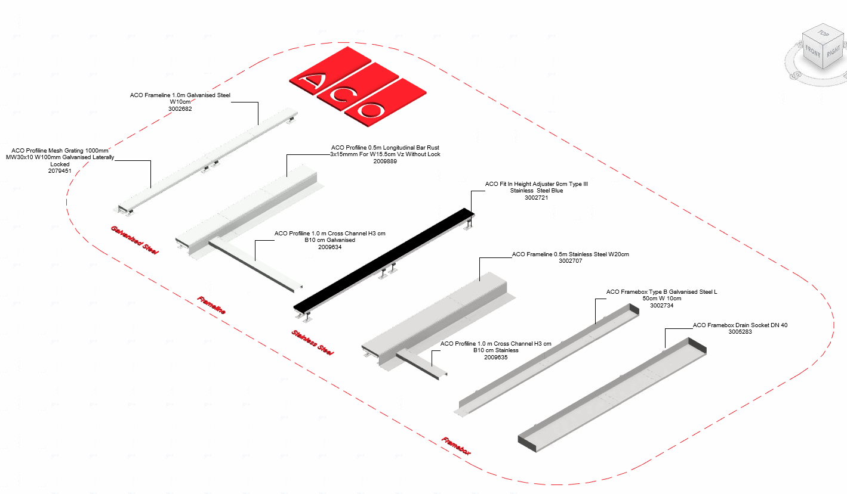

The family types are further classified based channel width and material as shown below;

- PF_WPB_Framebox_ACO
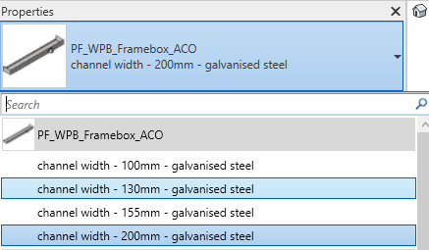
- PF_WPB_Frameline_ACO
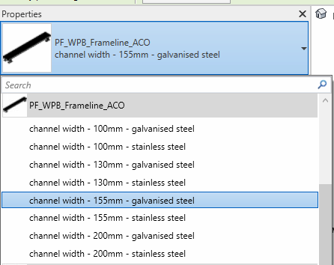

- PF_WPB_Frameline cross channel_ACO
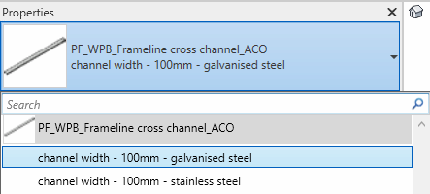

The user has to select the required family type in the drop down as shown above

Loading ACO Frameline and Framebox into the project:
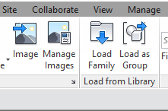
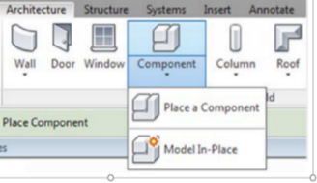
- Download the ACO Frameline and Framebox project file and save it to a suitable location

- Select any one of the family from ACO Frameline and Framebox
and load to your project

- Navigate to the “Insert” icon on the Revit ribbon and click “Load Family”

- The file can now be placed into your project. Navigate to the “Architecture/Component” icons on the Revit ribbon and click “Place a Component”

Placing of families

- Click on the model – At properties tool bar, it will display family name and types.

- It consists of families and family types, the user has to select the family type from the “Properties” drop down menu.

Arrangement of ‘N’ No. of families in the project

If the user wishes to place ‘n’ no. of families in the project ,then following steps needs to be followed;
- Go to Project Brower Floor Plan Level
- Place the required family PropertiesConstraints tab
- Right Click on the family as shownCreate Similar RSen_C_lengthEnter the length
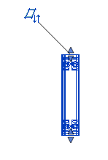
Note: By dragging the arrow the user can select the length in level plan

- All the families are work plane-based families, if needed they can be placed on sloped surfaces as well.

- Place the other family to the snapping point as shown below

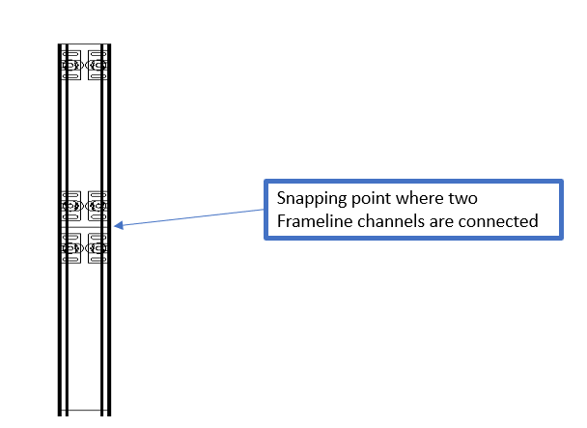
- Similarly, Framebox length can be varied

- Frameline and Framebox Template is available both in International Version and German Version

Functionality of Frameline and Framebox channel

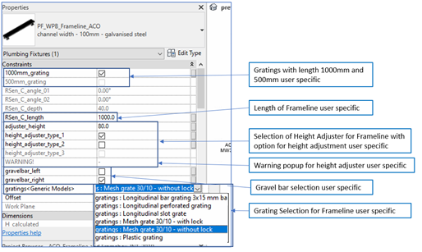

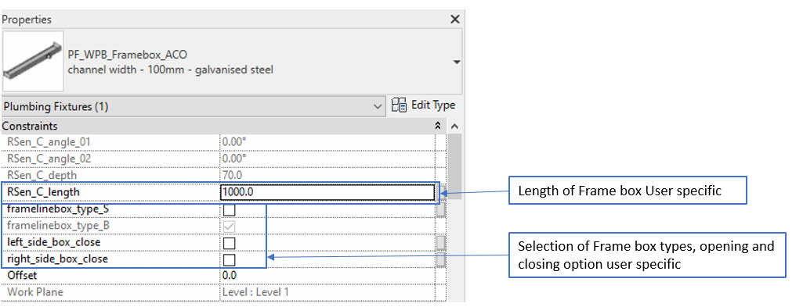

Frameline

- Selection of Length:
- Based on the RSen_C_length the SAP article no. will change(if the user enters RSen_C_length=<500mm,then the article no. assigned to 500mm channel will appear in BOM, if the user enters RSen_C_length>501mm,then SAP article no. assigned to 1000mm channel will appear in BOM.

- Selection of Gratings:
- Gratings can be selected from the generic container as per user requirement.
- There are nine gratings ;
- Mesh grate 30/10 with lock
- Mesh grate 30/10 without lock
- Longitudinal bar grating 3x15mm bar
- Longitudinal perforated grating
- Plastic grating
- Heel safe(rough)
- Heelguard(fine)
- Longitudinal slot grate
- Longitudinal bar grating
- Few gratings are available in galvanized steel version and all the gratings are available in stainless steel version but are limited to Frameline length and width. If for particular combination of Frameline and gratings, particular grating is not available, then in description we can see the instruction regarding with which material, length and width it is available, accordingly user has to select next available grating from the container
- If the user selects the RSen_C_length=<500mm ,then even if the user checks 1000mm grating, by default 500mm gratings SAP article no. will be displayed in the BOM.
- If the user selects the RSen_C_length>501mm ,then if the user checks 1000mm grating 1 no. of 1000mm gratings with its SAP article no. will be displayed, if the user checks 500mm gratings then 2 No’s of 500mm gratings with its SAP article no. will be displayed in the BOM.

- Selection of Height Adjuster:
- There are 3 types of height adjuster they are height_adjuster_type_1, height_adjuster_type_2 and height_adjuster_type_3.
- Height adjuster type 1 : Hmin= 60 ; Hmax=80mm
- Height adjuster type 2 : Hmin= 80 ; Hmax=100mm
- Height adjuster type 3 : Hmin= 100 ; Hmax=120mm

The user has to select the particular type and adjuster_height, same height will be reflected in the assembly. Suppose if the user enters adjuster_height greater or lesser than the range. Then by default the value will be taken as per the Hmin and Hmax values with respect to the type selected Simultaneously it will popup the warning displaying to select the suitable adjuster type as per product range. If the adjuster_height is less than minimum value or maximum value of all the adjuster types height limit then it will display warning “entered height is less than minimum value, please contact ACO for solution”/ “entered height is more than maximum value, please contact ACO for solution”. For adjuster_height within the range it will be updated in the assembly.
- Selection Gravel bar:
- Gravel bar can be selected as per user requirement towards left or right. Gravel bar type will change as per the Height adjuster type. SAP article no. with respect to the gravel bar selected will be displayed in the BOM

Framebox:

- Selection of Length:
- Framebox is available in two types(Type S and Type B) ,length 1000mm, and 500mm width 100/130/155/200mm. The length can be varied upto 1000mm ,as per that SAP article no. will be displayed in the BOM.
- The variation of length and its function is of same way as that of Frameline.
- Frameline can be opened and closed at either ends by using the check box left_side_box_close and right_side_box_close in the properties tab.

Frameline Cross Channel

- Selection of Length:
- Frameline cross bar is available length 1000mm, and 2000mm and width 100mm. The length can be varied upto 1000mm and 2000mm, SAP article no. will be displayed in a similar way as that of Frameline in BOM.

Material Library:
The ACO Frameline and Framebox file contains materials that are already pre-loaded into the components. When loading the ACO Frameline and Framebox file into your project the pre-loaded materials will automatically transfer through.

Schedules and quantities:

The information such as article number, GTIN data, weight, installation guidelines within the parameters is stored as “Shared Parameters” with LOD 400 so it can easily appear when creating a schedule and quantities in the project environment as follows;

