BIM User Guide: December 2021
ACO Powerlift-P

User Guide for Autodesk Revit files

ACO Powerlift-P Package

Powerlift-P is incorporated in a single Revit template along with accessories.
This template includes the family Powerlift-P in which the family types has been classified based on load class B125 and D400 and height as a drop down as follows;
- Duo load class B125 height 125mm
- Duo load class B125 top section with height 125mm
- Duo load class D400 top section with height 125mm
- Duo load class D400 top section with height 100mm
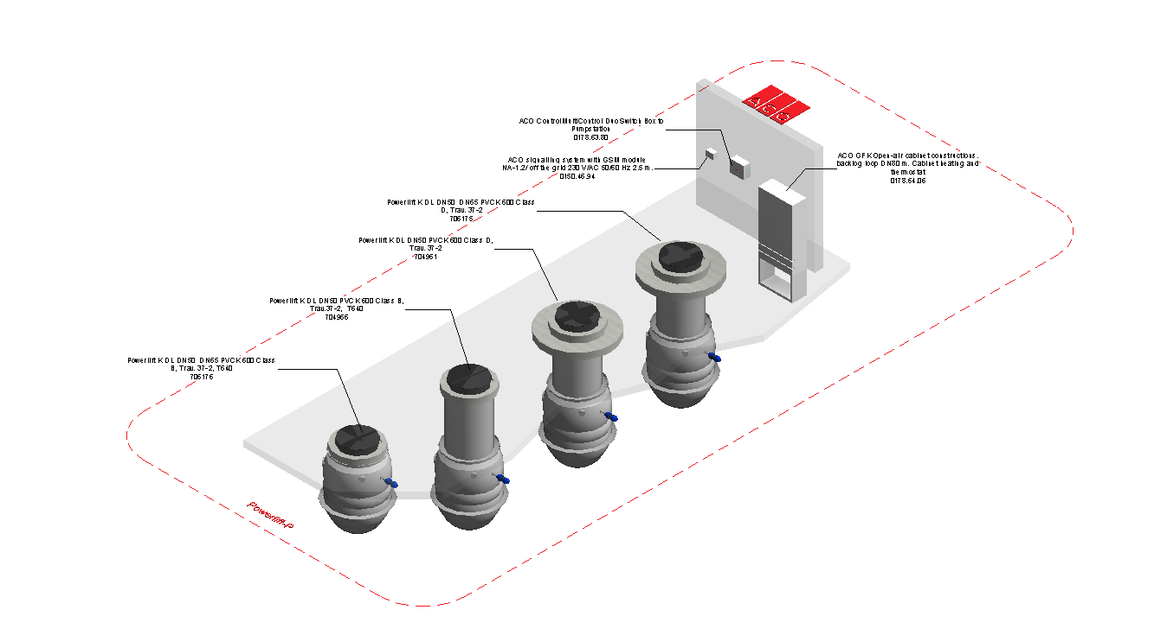

Loading ACO ACO Powerlift-P into the project:
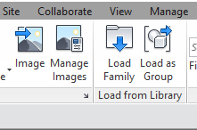
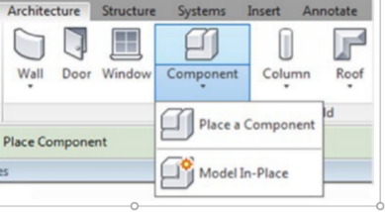
- Download the ACO Powerlift-P project file and save it to a suitable location

- Select any one of the family types from ACO Powerlift-P and
load to your project

- Navigate to the “Insert” icon on the Revit ribbon and click “Load Family”

- The file can now be placed into your project. Navigate to the “Architecture/Component” icons on the Revit ribbon and click “Place a Component”

Placing of families

- Click on the model – At properties tool bar, it will display family name and types.

- The user has to select the appropriate family type from the “Properties” drop down menu.

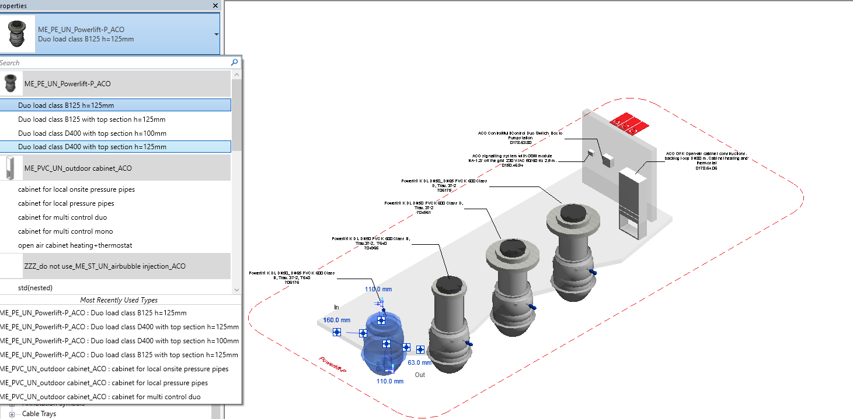

Selection of Accessories:

Click on the model – At properties tool bar, it will display list of accessories such as protection tube,pumps,pressure transducer, air bubble injection, float switch pump,floater signal unit, flush connection and extension guide tube. User can select by click the list as shown below

The installation depth has a minimum value of 2400mm and maximum value of 3000mm for Duo load class B125mm with top section and Duo load class D400 with top section and installation depth is 1830mm for Duo load class B125.

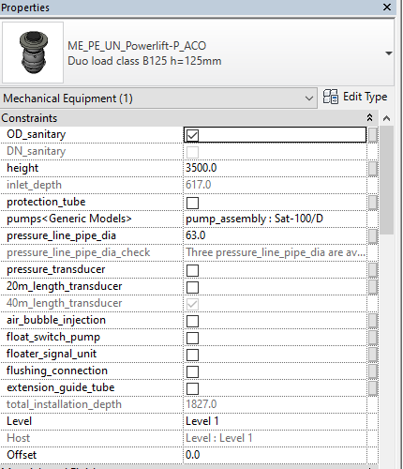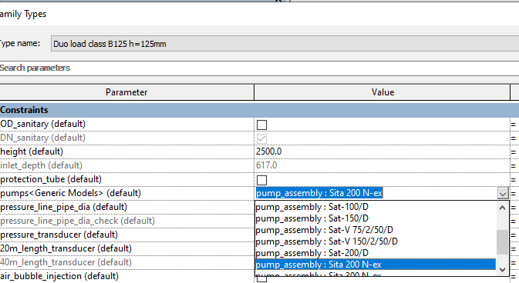

Material Library:
The ACO Powerlift-P file contain materials that are already pre-loaded into the components. When loading the ACO Powerlift-P file into your project the pre-loaded materials will automatically transfer through.

Schedules and quantities:

The information such as article number, GTIN data, weight, installation guidelines within the parameters is stored as “Shared Parameters” so it can easily appear when creating a schedule and quantities in the project environment as follows

