BIM User Guide: December 2021
ACO Muli-Max

User Guide for Autodesk Revit files

ACO Muli-Max Package

Muli-Max is incorporated in a single Revit template along with accessories.
This template includes the families based on load class as listed below ;
- Mulimax load class A15
- Duo cover placed loosely
- Mono cover placed loosely
- Mulimax load class B125
- Duo cover placed loosely
- Duo cover screwed shut odour-proof
- Mono cover placed loosely
- Mono cover screwed shut odour-proof
- Mulimax load class D400
- Duo cover placed loosely
- Duo cover screwed shut odour-proof
- Mono cover placed loosely
- Mono cover screwed shut odour-proof
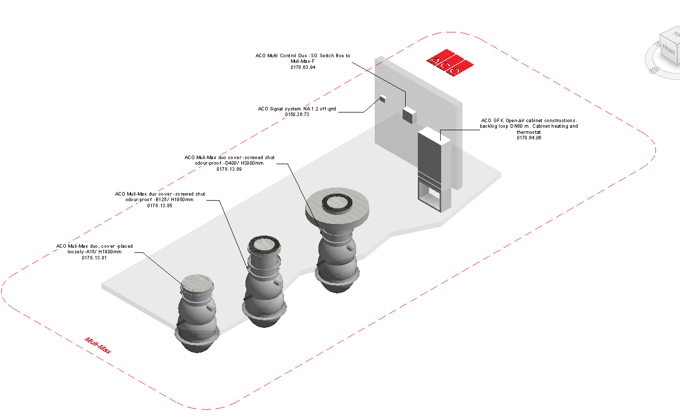

Loading ACO ACO Muli-Max into the project:
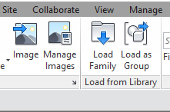
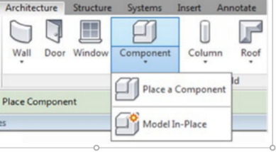
- Download the ACO Muli-Max project file and save it to a suitable location

- Select any one of the family types from ACO Muli-Max and
load to your project

- Navigate to the “Insert” icon on the Revit ribbon and click “Load Family”

- The file can now be placed into your project. Navigate to the “Architecture/Component” icons on the Revit ribbon and click “Place a Component”

Placing of families

- Click on the model – At properties tool bar, it will display family name and types.

- The user has to select the appropriate family type from the “Properties” drop down menu.

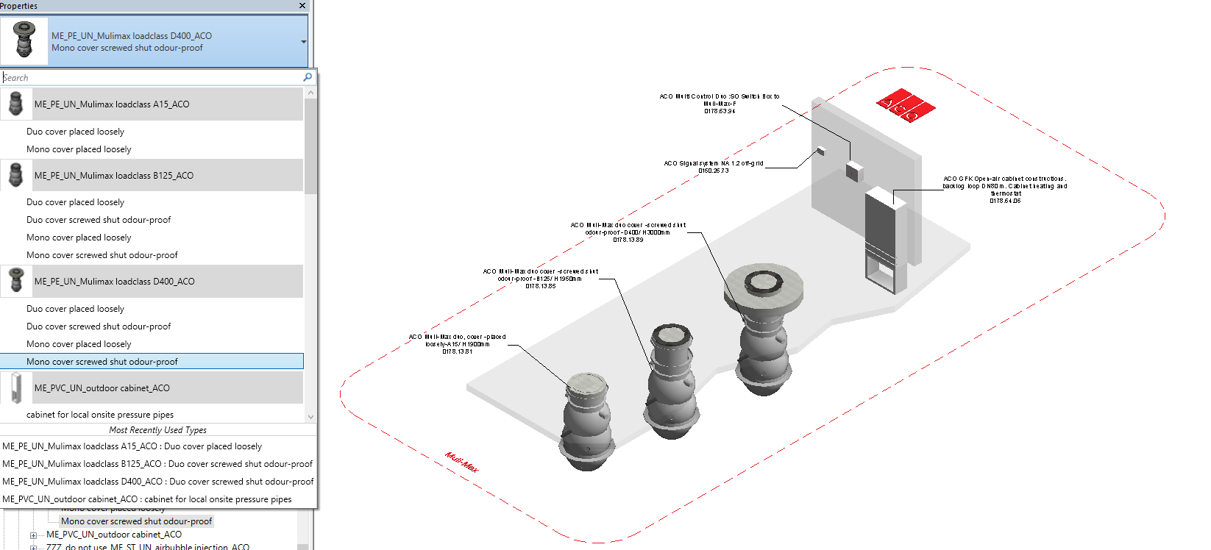

Selection of Accessories:

Click on the model – At properties tool bar, it will display list of accessories such as pressure transducer, drill connection seal inlets, air bubble injection, float switch pump, floater signal unit and flush connection . User can select by click the list as shown below

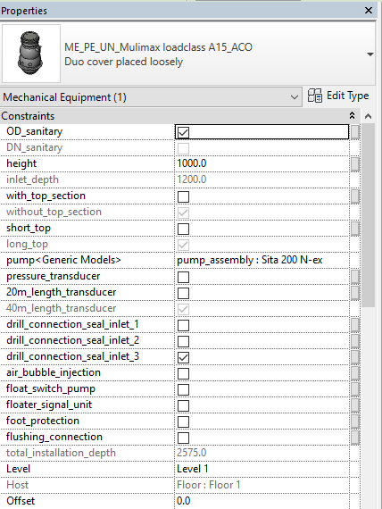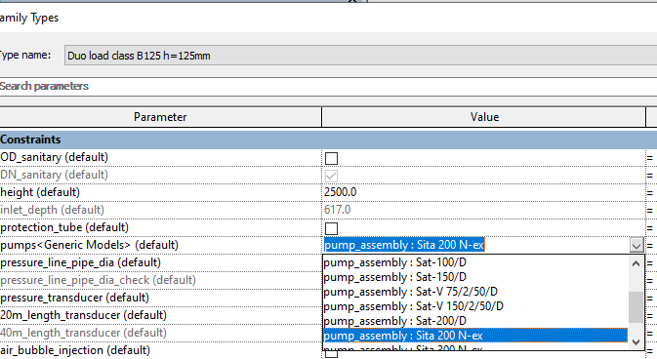

Material Library:
The ACO Muli-Max file contain materials that are already pre-loaded into the components. When loading the ACO Muli-Max file into your project the pre-loaded materials will automatically transfer through.

Schedules and quantities:

The information such as article number, GTIN data, weight, installation guidelines within the parameters is stored as “Shared Parameters” so it can easily appear when creating a schedule and quantities in the project environment as follows

