BIM User Guide: March 2022
ACO Civictop Manhole Cover

User Guide for Autodesk Revit files

ACO Civictop manhole cover Package
Civictop manhole cover is incorporated in a single Revit template along with its accessories. This template includes two families based on load class D 400 and material as shown below;
- PF_CI_WPB_frame Bituplan_cover cast iron_D 400
- PF_CI_WPB_frame BEGU_cover cast iron_D 400
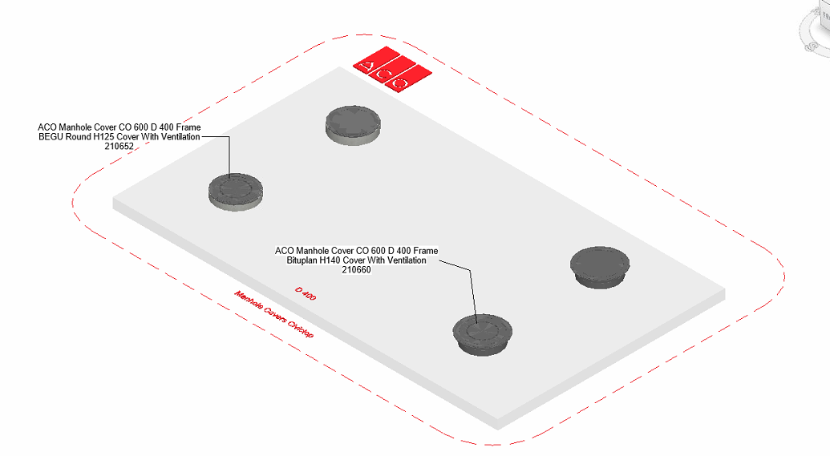
The family types are further classified based on clear opening, material and height as shown;
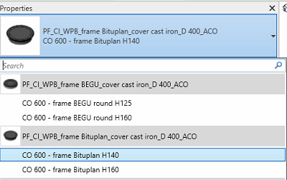

Loading ACO Civictop manhole cover into the project:
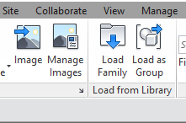
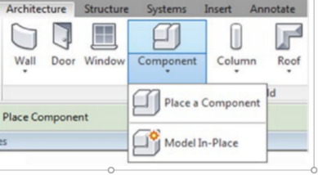
- Download the Civictop manhole cover project file and save it to a suitable location

- Select any one of the family from Civictop manhole and
load to your project

- Navigate to the “Insert” icon on the Revit ribbon and click “Load Family”

- The file can now be placed into your project. Navigate to the “Architecture/Component” icons on the Revit ribbon and click “Place a Component”

Placing of families

- Click on the model – At properties tool bar, it will display family name and types.

- It consists of two families and its family type, the user has to select the family type from the “Properties” drop down menu.
.
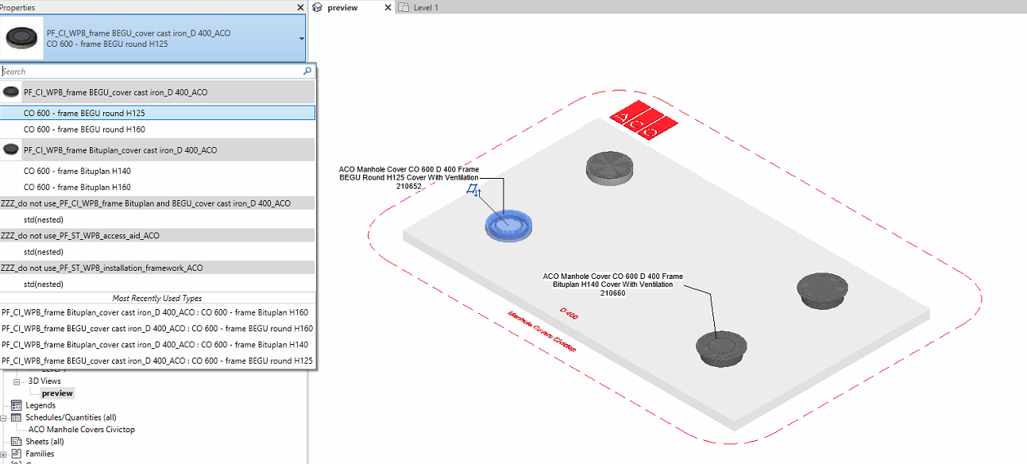

- PF_CI_WPB_frame Bituplan_cover cast iron_D 400

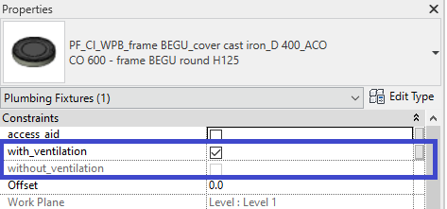
- Selection of Ventilation
The family is available with ventilation and without ventilation. The user has to select required option from the propertiesConstraints tab

- PF_CI_WPB_frame BEGU_cover cast iron_D 400

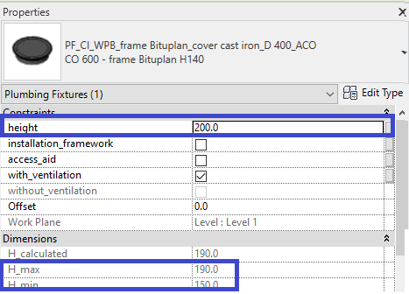
- Selection of Ventilation
The family is available with ventilation and without ventilation. The user has to select required option from the propertiesConstraints tab
- Selection Variable Height of frame
The family is available with adjustable height where;
Minimum Hight 150mm
Maximum Height190mm
- Suppose if the user selects the height within the specified limit then the family will work as per entered height.
- Suppose if the user selects the height greater than the maximum value then by default irrespective of height entered it will be locked to maximum limit of height.
- Suppose if the user selects the height lesser than the minimum value then by default irrespective of height entered it will be locked to minimum limit of height.

Workplane Based Families
The families are work plane-based families so they can be placed in uniform and sloped surface of road as shown below

Selection of Accessories:

Click on the model – At properties tool bar, it will display list of accessories such as access aid, installation frame work. User can select by click the list as shown below
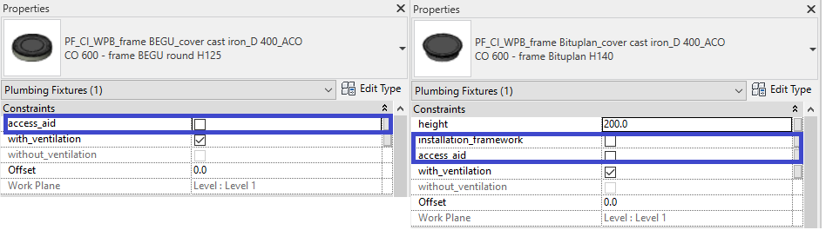

Material Library:
The ACO Civictop manhole cover file contains materials that are already pre-loaded into the components. When loading the ACO Civictop manhole cover file into your project the pre-loaded materials will automatically transfer through.

Schedules and quantities:

The information such as article number, GTIN data, weight, installation guidelines within the parameters is stored as “Shared Parameters” with LOD 400 so it can easily appear when creating a schedule and quantities in the project environment as follows

