BIM User Guide: January 2021
ACO KerbDrain

User Guide for Autodesk Revit files

ACO KerbDrain Packages

All ACO KerbDrain are incorporated in a single Revit template along with all accessories.
This template includes the following families:
- KerbDrain-305 along with accessories
- KerbDrain-480 along with accessories

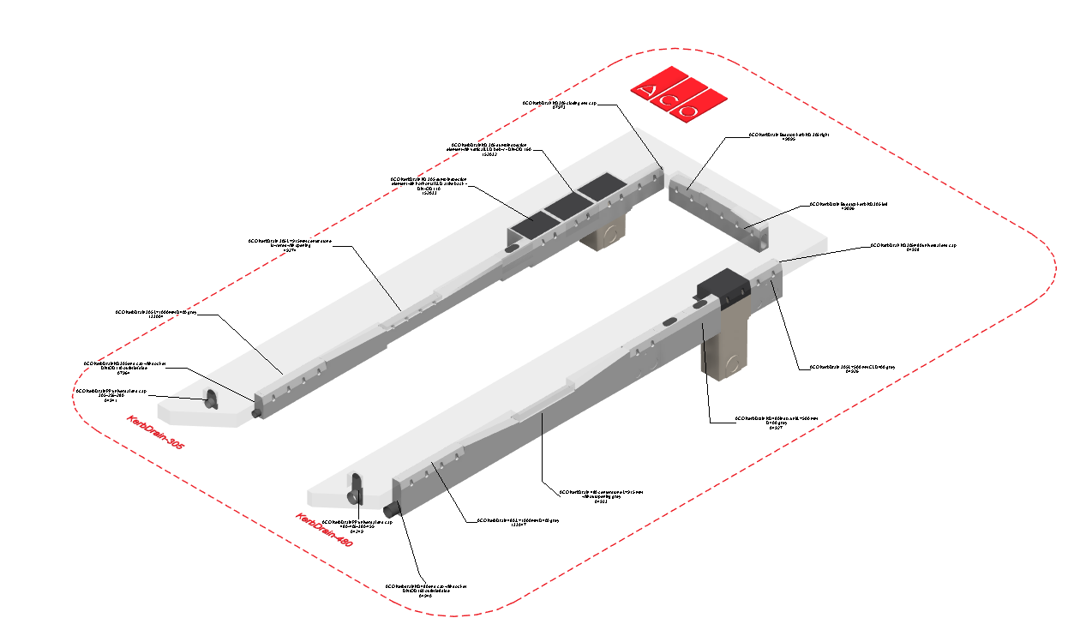

Loading ACO KerbDrain into the project:

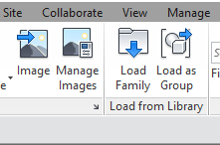
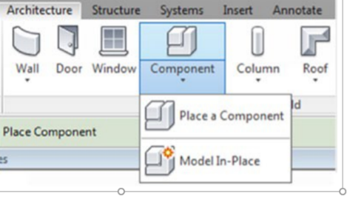
- Download the ACO KerbDrain project file and save it to a suitable location

- Select any one of the family from ACO KerbDrain,
load to your project

- Navigate to the “Insert” icon on the Revit ribbon and click “Load Family”

- The file can now be placed into your project. Navigate to the “Architecture/Component” icons on the Revit ribbon and click “Place a Component”

Placing of families

- Click on the model – At properties tool bar, it will display family name and types.

- Every family consists of different types, the user has to select the appropriate family type from the “Properties” drop down menu.

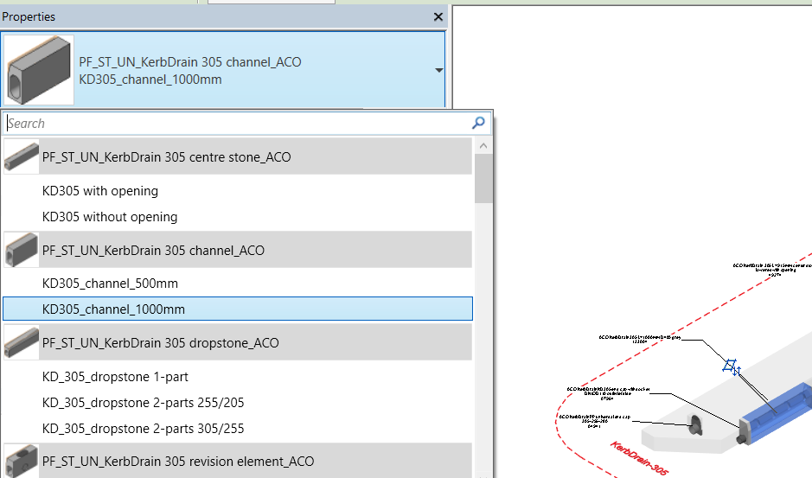

Selection of Accessories:

- Click on the model – At properties tool bar, it will display accessories list, the user can select by click the list as shown below
- Also we can select left and right position for Drop stone from the dropdown menu.

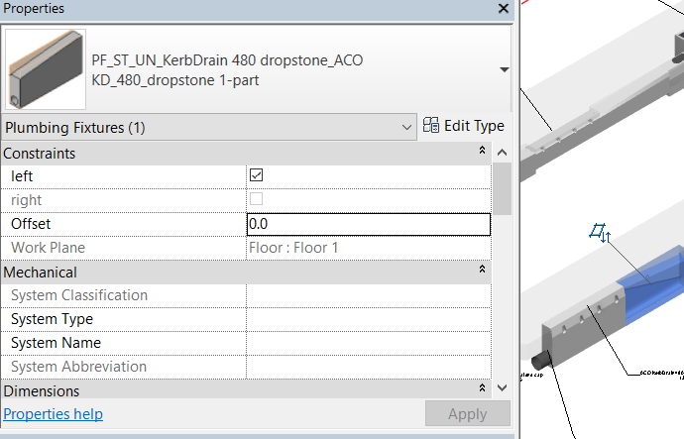

Material Library:
The ACO KerbDrain files contain materials that are already pre-loaded into the components. When loading the ACO KerbDrain files into your project the pre-loaded materials will automatically transfer through.

Schedules and quantities:

The information such as article number, GTIN data, weight, installation guidelines within the parameters is stored as “shared Parameters” so can easily be appeared when creating a schedule and quantities in the project environment.

