BIM User Guide: March 2022
ACO Multitop cover

User Guide for Autodesk Revit files

ACO Multitop cover Package
Multitop cover is incorporated in a single Revit template along with accessories.
This template includes the following families:

- Frame Bituplan cover cast iron D 400
- Frame BEGU cover cast iron D 400
- Frame cast iron cover cast iron D 400
- Frame BEGU cover cast iron F 900
- Frame cast iron cover cast iron F 900
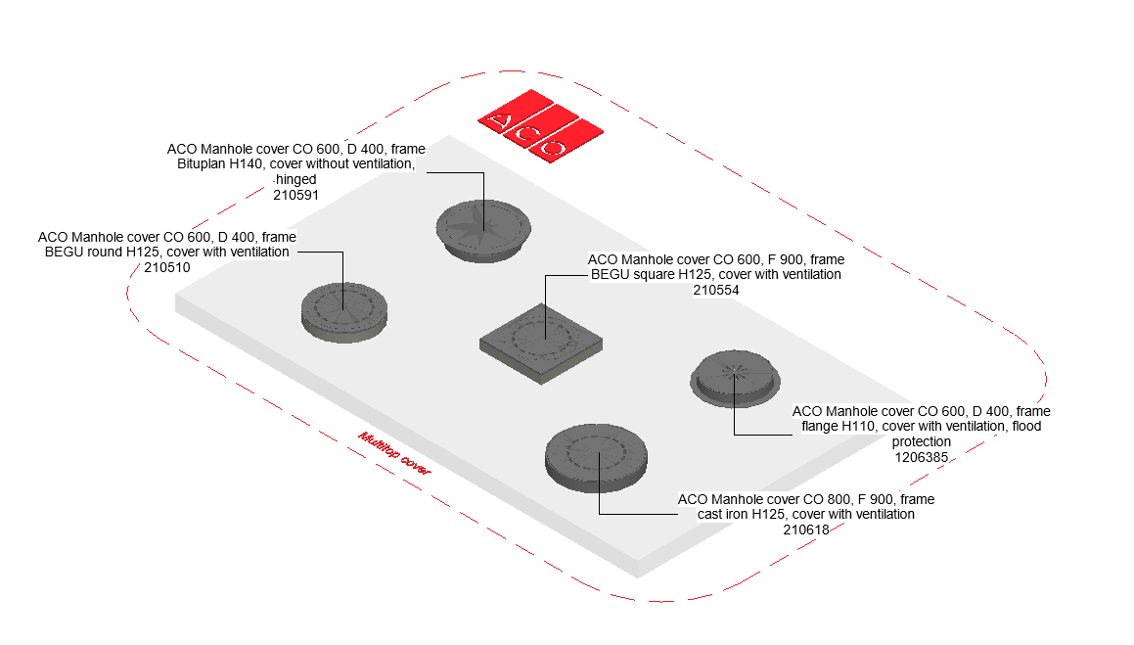

Loading ACO Multitop cover into the project:
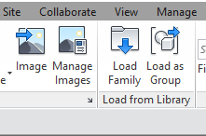
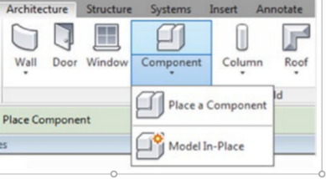
- Download the ACO Multitop cover project file and save it to a suitable location

- Select any one of the family from ACO Multitop cover and
load to your project

- Navigate to the “Insert” icon on the Revit ribbon and click “Load Family”

- The file can now be placed into your project. Navigate to the “Architecture/Component” icons on the Revit ribbon and click “Place a Component”

Placing of “Frame Bituplan cover cast iron D 400 family”
- Click on the model – At properties tool bar, it will display family name and types
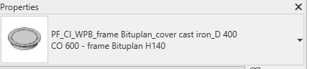

- Family consists of 5 family types; the user can select the family type from the “Properties” drop down menu

- After selecting the family type, the user can have multiple options like, selection of lettering frame, ventilation opening, height adjustment and related accessories as shown in image
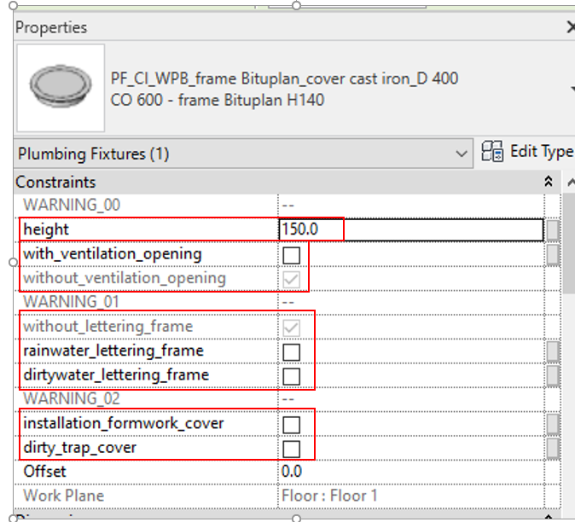

- Frame Height adjustment: The user can adjust the frame height by entering value range limits by looking H_min and H_max range and enter required height within the limits, if user enters value below or above the limits then warning pop up will display
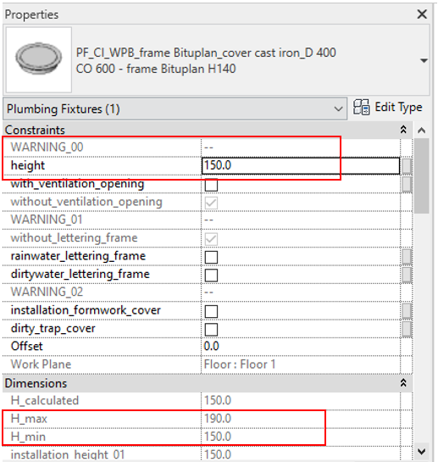

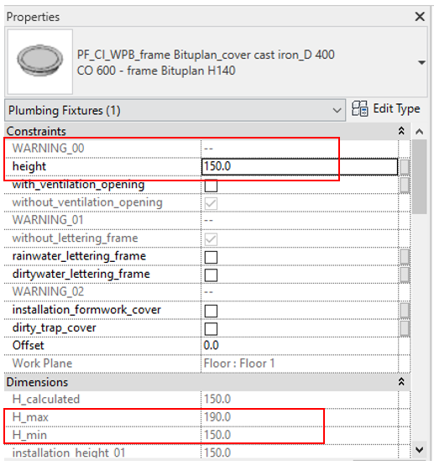

- Selection of Ventilation: The user can select with ventilation opening or without ventilation by selecting check box as shown in below image.
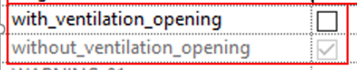

- Selection of Lettering frame: By default, without lettering frame will be selected in all the family type, if the user needs rainwater lettering frame or dirty water lettering frame then the user as to select check box as shown in image.
In case, if user select multiple check box, then warning pop up will display.

- Selection of Accessories: Finally, the user can select accessories such as form cover and dirty trap, if accessories are not used in family type, then the warning pop will display.
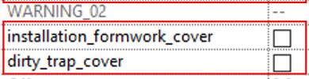

Note: Similarly for other families have same functionality as explained for “Frame Bituplan cover cast iron D 400 family”

Workplane Based Families: The families are work plane-based families so they can be placed in flat surface and sloped surface of road as shown below

Material Library:
The ACO Multitop cover file contains materials that are already pre-loaded into the components. When loading the ACO Multitop cover file into your project the pre-loaded materials will automatically transfer through.

Schedules and quantities:

The information such as article number, GTIN data, weight, installation guidelines within the parameters is stored as “Shared Parameters” with LOD 400 so it can easily appear when creating a schedule and quantities in the project environment as follows

